Software Design Document
(SDD) Report



Project Title : GlowHub – Imported Makeup & Beauty Store for Pakistan

Submitted by :
Hina Majeed
F22BINFT1M01168 (3M)

Submitted to :
Ms. Sara Fareed

Department of Information Technology
Faculty of Computing
The Islamia University of Bahawalpur

Table of Contents
 | Summary | 3
1 | Introduction  1.1 Purpose of the Document  1.2 Scope of the System  1.3 Definitions, Acronyms, and Abbreviations | 4
2 | System Overview  2.1 User Classes and Characteristics  2.2 Operating Environment | 5
3 | Design Considerations  3.1 Assumptions  3.2 Constraints  3.3 Design Goals  3.4 Design Methodology | 5
4 | System Architecture  4.1 Architectural Overview  4.2 High-Level Architecture Diagram  4.3 Architectural Style | 6
5 | Data Design  5.1 Database Overview  5.2 Data Entities and Descriptions  5.3 Entity Relationship Diagram  5.4 Data Integrity and Validation | 7
6 | Component Design  6.1 Major System Components  6.2 AI Engine Design  6.3 AR Rendering Module | 8
7 | Interface Design  7.1 User Interface Design Principles  7.2 User Interface Screens  7.3 Input Validation and Error Handling | 8
8 | UML Diagrams Description  8.1 Class Diagram  8.2 Sequence Diagram  8.3 Use Case Diagram | 9
9 | Security Design  9.1 Authentication and Authorization  9.2 Data Security and Privacy | 11
10 | Assumptions and Constraints | 11
11 | Future Enhancements | 11
12 | Conclusion | 11

Summary
GlowHub is a web-based e-commerce platform designed for customers in Pakistan to discover and purchase imported makeup and beauty products. The system enables browsing by brand/category, comparing prices in PKR, adding items to cart, placing orders or pre-orders, and tracking deliveries. GlowHub also includes an AI-based recommendation engine (for personalized product suggestions) and an AR Try-On module (to preview shades like lipstick/eyeliner virtually) to improve buying confidence and user experience.

1. Introduction

1.1 Purpose of the Document
This SSD document explains the design of GlowHub, including system architecture, data design, component design, interfaces, UML descriptions, and security considerations. It is intended for academic submission and for developers to implement the system consistently.

1.2 Scope of the System
GlowHub provides:
- Product browsing (brands, categories, filters, search)
- Product details (images, shade info, price in PKR, reviews)
- Cart and checkout
- Payments (COD + local gateways)
- Pre-orders for out-of-stock imported items
- Order tracking and notifications
- Admin panel for products/orders/users/promotions
- AI recommendations (personalized suggestions)
- AR Try-On (virtual shade preview)

1.3 Definitions, Acronyms, and Abbreviations
- SSD: Software System Design
- SRS: Software Requirements Specification
- UI: User Interface
- UX: User Experience
- API: Application Programming Interface
- DB: Database
- JWT: JSON Web Token
- RBAC: Role-Based Access Control
- AR: Augmented Reality
- PKR: Pakistan Rupee
- COD: Cash on Delivery
- CDN: Content Delivery Network

2. System Overview

2.1 User Classes and Characteristics
- Guest User
  - Can browse/search products and view details
  - Encouraged to sign up for checkout and wishlist
- Registered Customer
  - Places orders/pre-orders, manages cart, wishlist, addresses
  - Views order history, reviews products, uses AR try-on
  - Receives recommendations based on activity
- Admin
  - Manages products, brands, categories, pricing, stock
  - Manages orders, customers, refunds, promotions, banners
  - Views analytics (sales, popular products, conversion)
- Support/Operations Staff (Optional Role)
  - Handles order verification, shipment updates, customer queries

2.2 Operating Environment
- Client Side: Web browser (Chrome/Edge/Safari), responsive for mobile + desktop
- Frontend: React.js (or Next.js for SEO-friendly pages)
- Backend: Node.js (Express) REST API (alternative: Django/REST)
- Database: MySQL (relational) or MongoDB (document)
- Payments: COD + integrations such as JazzCash/EasyPaisa (optional)
- Hosting: Cloud server (AWS/Azure/DigitalOcean) + CDN for images
- AR: WebAR using WebGL/Three.js + WebXR (where supported)

3. Design Considerations

3.1 Assumptions
- Users have stable internet access and modern browsers
- Product data (images, shades, descriptions) is available from suppliers
- PKR conversion rules are configured and updated by admin
- AR try-on will support selected product types first (e.g., lipstick)

3.2 Constraints
- Payment gateway policies and integration limits
- AR accuracy depends on device camera quality and browser support
- Imported product stock may change; pre-order workflow must handle delays
- Must comply with privacy and data protection best practices

3.3 Design Goals
- Fast, clean, mobile-friendly shopping experience
- Secure authentication and safe payments
- Easy admin management and scalable catalog
- Personalized shopping via AI recommendations
- Confidence-building AR try-on to reduce returns

3.4 Design Methodology
- Layered architecture (UI → API → Services → DB)
- RESTful API design with clear endpoints
- Agile development (iterations + testing each module)
- UML modeling for clarity (use case, sequence, class)
- Reusable components in UI (cards, filters, modals)

4. System Architecture

4.1 Architectural Overview
GlowHub uses a layered, service-oriented architecture:
- Presentation Layer (Frontend UI)
- Application Layer (Backend API + Business Logic)
- Data Layer (Database + Storage)
- Supporting Services (AI engine, AR module, notifications)

4.2 High-Level Architecture Diagram
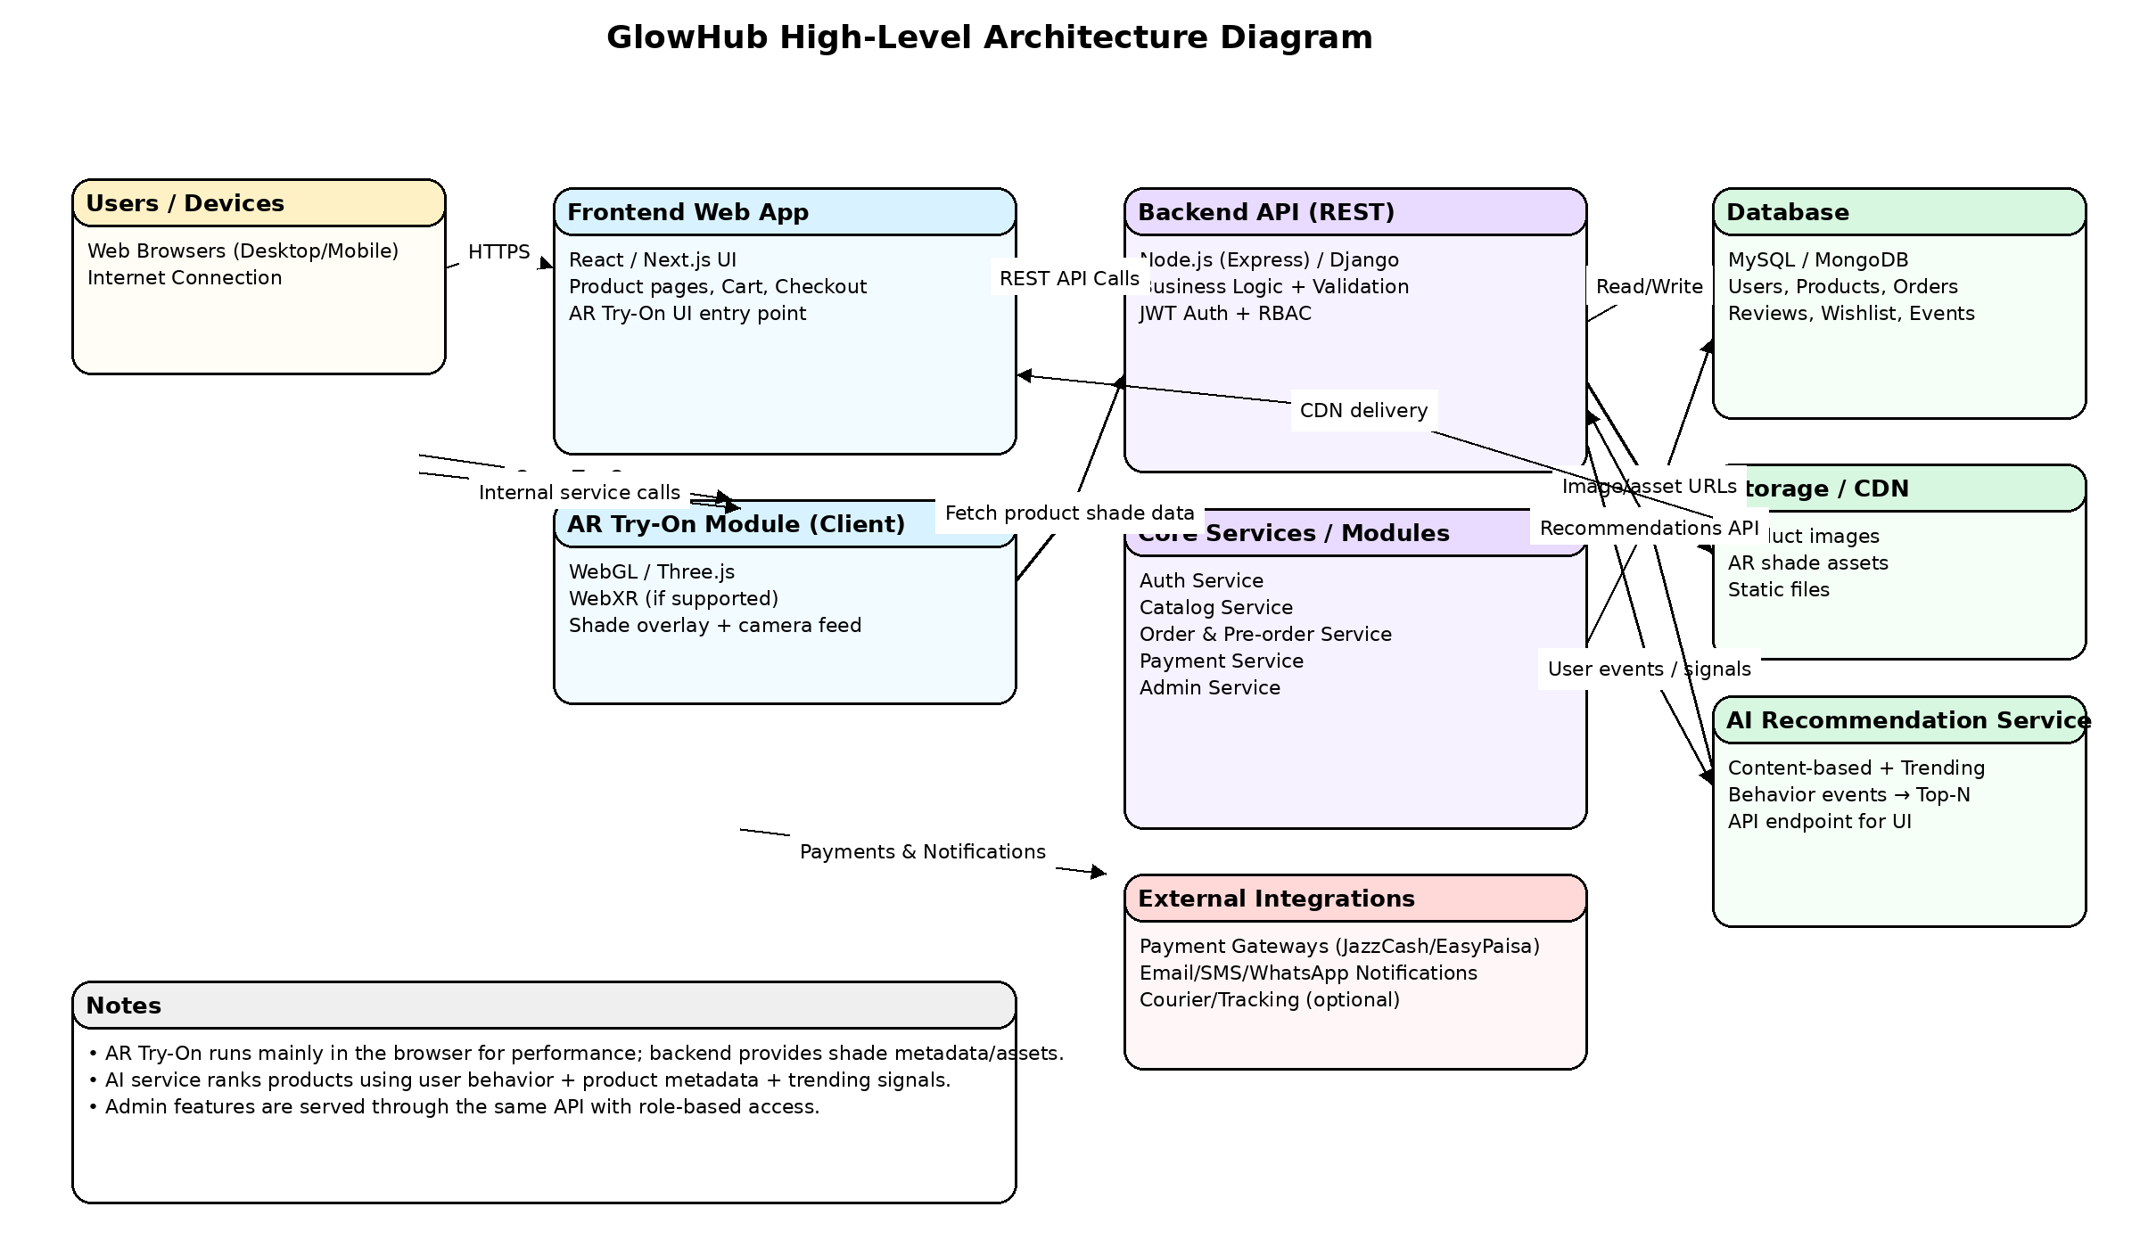

4.3 Architectural Style
- Layered + Modular Services
- REST API with separate services/modules:
  - Auth Service
  - Product/Catalog Service
  - Order & Checkout Service
  - Payment Integration Service
  - Recommendation Service (AI)
  - Admin Management Service

5. Data Design

5.1 Database Overview
A relational schema (MySQL) is suitable for strong consistency in orders/payments, while product images can be stored in object storage. Key design focus:
- Normalized core entities (Users, Products, Orders)
- Indexing for search and filtering
- Audit logs for orders and payments

5.2 Data Entities and Descriptions
- User: customer profile, login credentials, role
- Address: delivery addresses per user
- Brand: international brand info
- Category: product categories (makeup, skincare, fragrance)
- Product: title, description, pricePKR, stock, images, shade metadata
- Inventory: stock per product, reorder/pre-order flags
- Cart: active shopping cart per user/session
- CartItem: product + quantity
- Order: order header (user, total, status, delivery info)
- OrderItem: each product line in an order
- Payment: method, status, transaction reference
- Review: rating and comment by user
- Wishlist: saved products
- PreOrderRequest: requested imported items if out of stock
- RecommendationEvent: user activity logs (view/click/add-to-cart)

5.3 Entity Relationship Diagram (ERD)

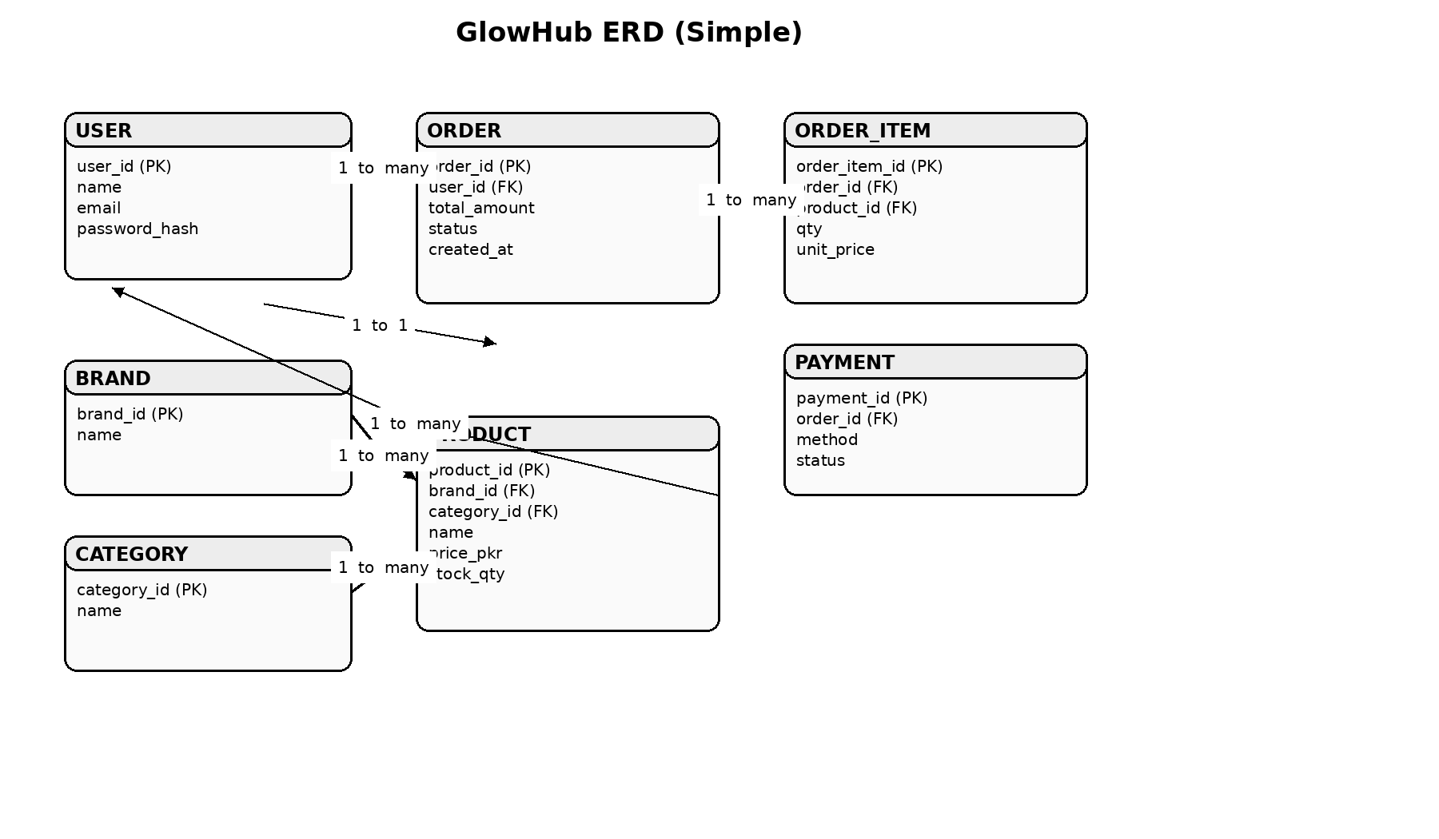5.4 Data Integrity and Validation
- Primary keys on all tables; foreign keys enforced for Orders/Items/Payments
- Constraints
  - rating between 1–5
  - quantity > 0
  - product price >= 0
- Indexes
  - Product(name, brandId, categoryId, price)
  - Order(userId, createdAt, status)
- Validation
  - email format, phone format (PK)
  - address required fields
  - payment status transitions controlled (Pending → Paid/Failed)

6. Component Design

6.1 Major System Components
- Frontend UI
  - Home, categories, search/filter, product pages
  - Cart, checkout, profile, order tracking
  - AR Try-On screen (supported devices)
- Backend API
  - Auth & RBAC
  - Catalog management
  - Order processing + payments
  - Pre-order handling
  - Admin dashboard APIs
- Database & Storage
  - MySQL for core data
  - Image storage (CDN/object storage)
- AI Recommendation Service
  - Suggests products based on behavior + similarity
- AR Rendering Module
  - Renders virtual makeup overlays on user camera

6.2 AI Engine Design
Goal: Personalized recommendations (e.g., “You may also like”, “Similar products”, “Trending in Pakistan”).
Inputs
- User events: views, searches, add-to-cart, purchases
- Product metadata: brand, category, price range, shade, skin type tags
- Popularity signals: ratings, sales count
Approach
- Phase 1 (Simple & effective):
  - Content-based filtering (similar category/brand/shade/price)
  - Popularity + trending in PK
- Phase 2 (Advanced):
  - Collaborative filtering (users with similar behavior)
  - Hybrid ranking: score = similarity + popularity + userAffinity
Outputs
- Top-N product recommendations per user/session
- “Similar items” per product page

6.3 AR Rendering Module
Purpose: Allow users to preview shades (lipstick, blush, foundation tone hints).
Design
- Client-side rendering for performance
- Uses camera feed + face landmarks (where supported)
- Applies color overlay with opacity + blending for realism
Key Features
- Shade selection from product variant list
- Before/after toggle
- Snapshot capture (optional)
- Works best on modern mobile browsers

7. Interface Design

7.1 User Interface Design Principles
- Mobile-first, responsive layout
- Minimal clicks to checkout
- Consistent typography, spacing, and buttons
- Clear price display in PKR and discount tags
- Fast search and filters (brand, category, price, rating)

7.2 User Interface Screens
- Landing/Home (featured brands, best sellers, offers)
- Category listing + filters
- Search results
- Product details (gallery, shades, reviews, AR button)
- Cart
- Checkout (address + shipping + payment)
- Order confirmation + tracking
- User profile (addresses, orders, wishlist)
- Admin: dashboard, products, orders, promotions

7.3 Input Validation and Error Handling
- Form validation (email/phone/address required)
- Payment failures show clear retry instructions
- Stock checks at checkout to prevent overselling
- Friendly error pages (404, server error)
- Logging errors for admin debugging

8. UML Diagrams Description

8.1 Class Diagram (Description)

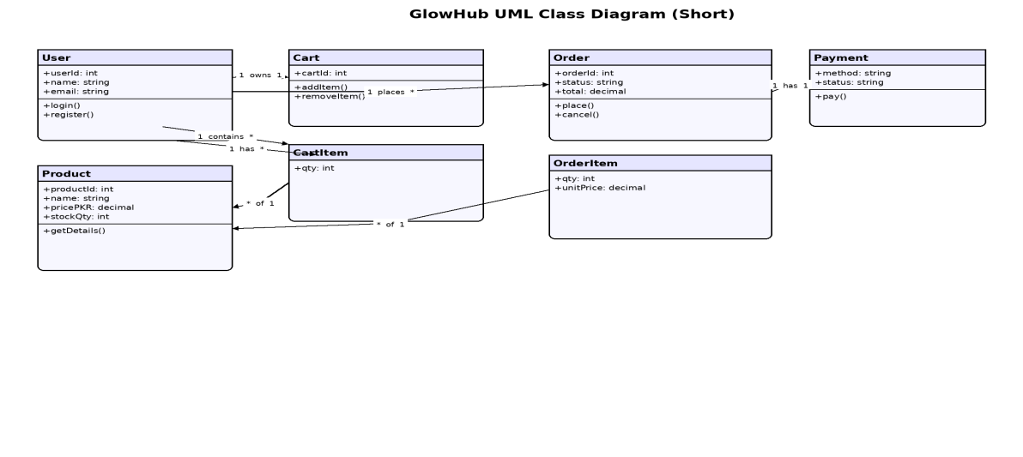
Main classes and relations:
- User has many Address, Order, Review, WishlistItem
- Product belongs to Brand and Category, has many Review
- Order has many OrderItem, has one Payment
- Cart has many CartItem

8.2 Sequence Diagram (Place Order – Description)

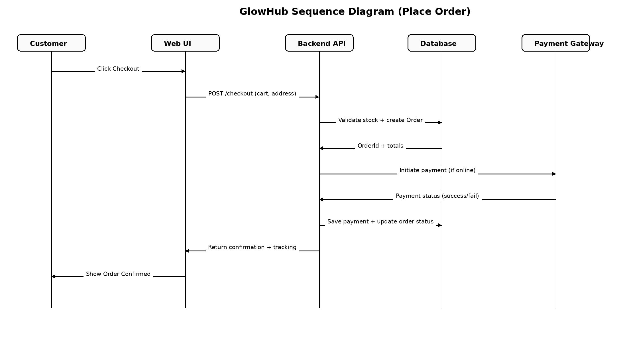
- User clicks Checkout
- UI sends request to API: validate cart + address
- API checks stock and calculates totals
- API creates Order (Pending) + OrderItems
- Payment initiated (COD or gateway)
- Payment result saved
- Order status updated (Confirmed/Paid)
- UI shows confirmation + tracking ID

8.3 Use Case Diagram (Description)

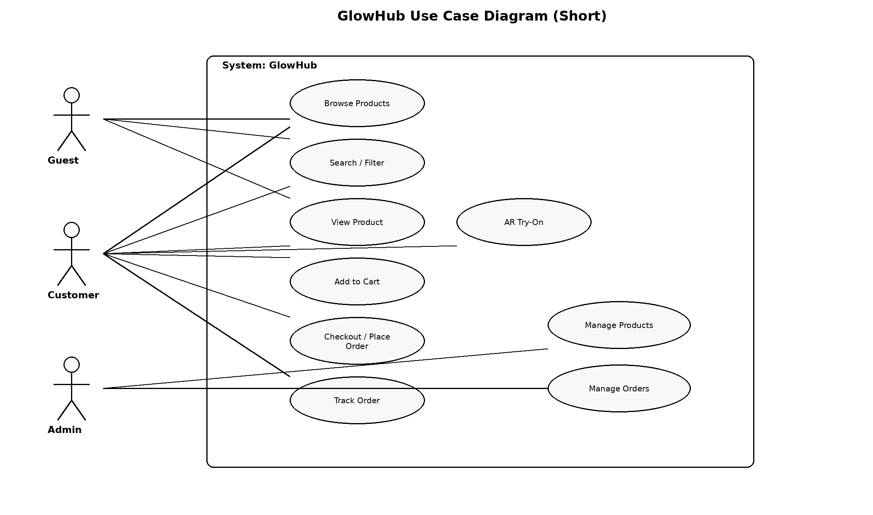

9. Security Design

9.1 Authentication and Authorization
- Authentication via JWT (access + refresh tokens)
- Password hashing (bcrypt/argon2)
- RBAC roles: Customer, Admin, Support
- Secure session handling and token expiration
- Optional: email/OTP verification for account safety

9.2 Data Security and Privacy
- HTTPS for all traffic
- Input sanitization to prevent SQL injection/XSS
- Rate limiting on login and APIs
- Sensitive data encryption at rest where needed
- Minimum collection of user data (privacy-by-design)
- Audit logs for admin actions and order/payment events

10. Assumptions and Constraints
Assumptions
- Stable supplier/product information availability
- Users have email/phone for verification and delivery contact
- Initial AR module supports limited product types
Constraints
- Payment gateway rules and API uptime
- Delivery delays for imported goods (pre-order workflow required)
- AR limitations on older devices/browsers

11. Future Enhancements
- Mobile app (Android/iOS)
- Multi-vendor marketplace (different sellers)
- Live chat + AI beauty assistant
- Loyalty points and referral system
- Subscription boxes (monthly beauty kits)
- Advanced analytics dashboard for admin
- More AR categories (foundation matching, skincare routines)

12. Conclusion
GlowHub is designed as a scalable, secure, and user-friendly e-commerce platform for imported beauty products in Pakistan. The proposed architecture supports core shopping features, robust data management, secure payments, and modern enhancements such as AI-driven recommendations and AR try-on. This SSD provides a complete design blueprint for implementation and evaluation.

